CURRICULUM VITAE
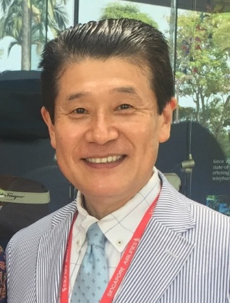
Tomohiro Ezaki D.D.S., M.S.D.

＊Personal Information
Date of Birth: 10th September, 1957

＊Education / Post Graduate training
April 1976~March 1982
*Graduation of Fukuoka dental college

September 1987~ September1989
*Boston University Goldman School of Dental Medicine
Certificate of Advanced Graduate Study Prosthodontics
September 1989~January 1991
*Boston University Goldman School of Dental Medicine
Master of Science in Dentistry in Prosthodontics

May 1991~January 1997
*International Dental Academy in Tokyo
Director of Fellowship of Full time school
September 2010
Acquisition of DGZI Expert
September 2011
Acquisition of DGZI Specialist
Present Position
March 1997 ~Present
*Director of Ezaki dental clinic opening of business in Tokyo Japan
March 2016~
*A member and vice president of Dental Arrow Study group for Dentist, Dental hygienist, Dental assistant and Dental technician in Tokyo established in 2016.

